Cardiology Critical Care Rotation:

General goals: The goal of rotating in the cardiac intensive care unit is to train fellows in the care of acute, life-threatening cardiovascular conditions including but not limited to acute coronary syndromes and associated mechanical complications, acutely decompensated heart failure with and without mechanical circulatory support, circulatory collapse/shock, complex ventricular arrhythmias, unstable conduction disturbances, pericardial tamponade, aortic dissection, hypertensive emergency, massive pulmonary embolism, and severe pulmonary hypertension. Fellows will be able to integrate clinical, electrocardiographic, hemodynamic, and imaging data to manage acutely ill patients. Fellows will be expected to take a leading role in the care of patients and housestaff education, as well as interact professionally with patients, families, and all members of the care team.

Objectives:
1st rotation (~1 month):
-Recognize differential diagnosis of shock and hemodynamic characteristics of each type.
-Interpret hemodynamic data and apply to the management of the patient.
-Understand indications, contraindications, and mechanism of action of vasoactive, inotropic, anticoagulant, antiplatelet, and fibrinolytic medications.
-Manage patients with acute coronary syndromes including associated rhythm disturbances and mechanical complications of acute myocardial infarction, initially with supervision.
-Diagnose and treat hypertensive emergency.
-Diagnose and manage acutely decompensated heart failure, understanding indications for inotropic therapies and mechanical circulatory support, initially with supervision.
-Review types of mechanical circulatory support and their indications/contraindications.
-Diagnose and manage acute, severe valvular heart disease, initially with supervision.
-Diagnose and treat unstable arrhythmias with medications and/or defibrillation, initially with supervision.
-Diagnose pericardial tamponade and recognize indications for pericardiocentesis.
-Review indications for surgery in aortic dissection.
-Recognize indications for oxygen supplementation, endotracheal intubation, and mechanical ventilation.
-Review indications for hemodialysis.
-Apply hypothermia protocols for patients with cardiac arrest.
-Perform central venous catheter insertion, arterial catheter insertion, and emergency echocardiography independently.
-Perform pulmonary artery catheter insertion and temporary transvenous pacemaker implantation under supervision.
-Manage spontaneous or treatment-related acute bleeding complications.
-Participate in family meetings, integrate palliative care, and assist in discussions regarding end-of-life care and transition to hospice.

2nd rotation (~2 months), In addition to the above:
-Review risk stratification scoring systems for acute coronary syndrome, acutely decompensated heart failure, and pulmonary hypertension.
-Evaluate and manage severe pulmonary hypertension, including indications, contraindications, and mechanism of action of pharmacologic therapies.
-Recognize indications for urgent/emergent valve intervention in patients with severe valvular heart disease.
-Diagnose complications of transcatheter valve interventions and determine appropriate interventions for management.
-Diagnose and manage hemodynamic instability after cardiac surgery.
-Participate in peri-operative care of cardiac transplant and left ventricular assist device recipients as a part of the management team.
-Review treatment of hypotension in specific populations such as cardiogenic shock, hypertrophic obstructive cardiomyopathy, right ventricular infarction, massive pulmonary embolism, severe pulmonary hypertension, pericardial tamponade, and distributive shock.
-Perform pulmonary artery catheter insertion and temporary transvenous pacemaker implantation independently.
-Perform pericardiocentesis in emergency settings.
-Lead the CCU team of residents and other learners, with appropriate faculty supervision.
-Complete COCATS level 1 training (total 2 months).

Fellow responsibilities: (program specific)

Attending responsibilities: (program specific)

Suggested reading:
Cardiac Intensive Care; David L. Brown
The ICU Book; Paul Marino
Textbook of Clinical Hemodynamics; Michael Ragosta

Evaluation of trainee: (program specific)

Evaluation of rotation: (program specific)

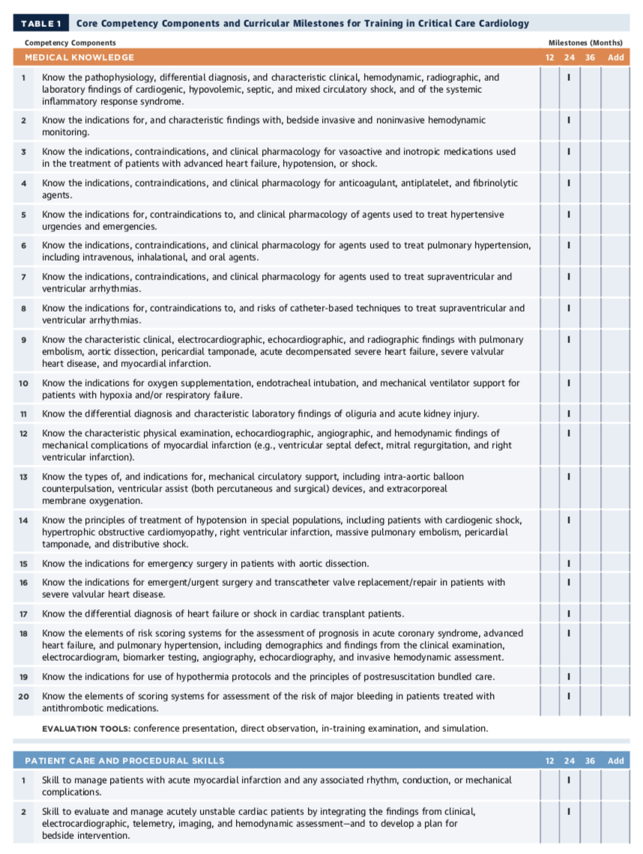

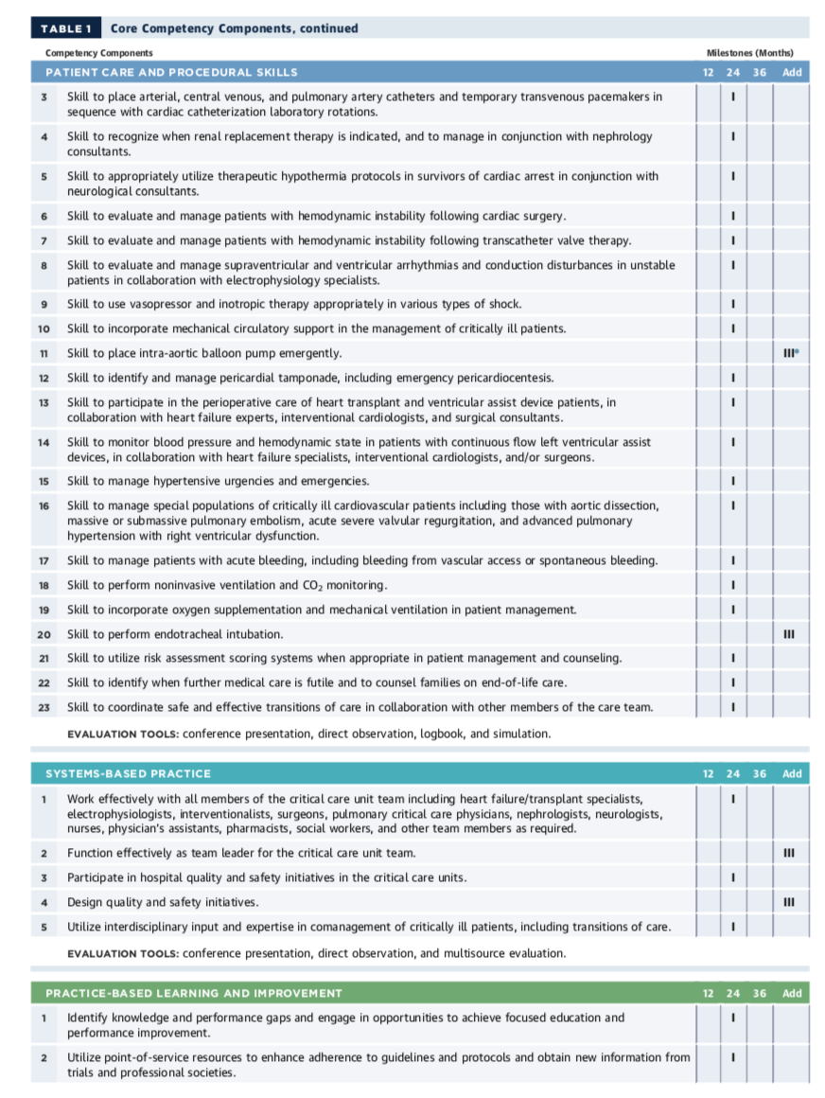

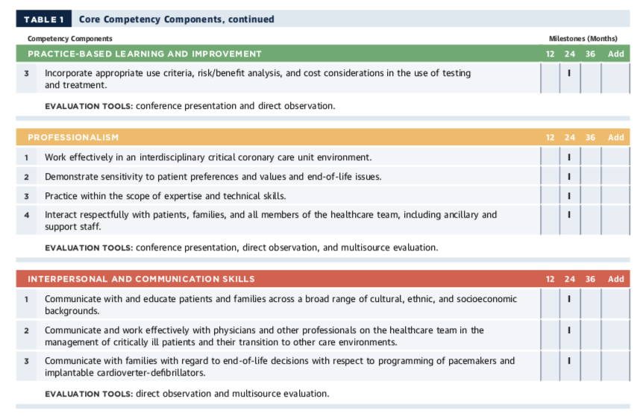

ACC 2015 Core Cardiovascular Training Statement (COCATS 4). J Am Coll Cardiol. 2015;65:1721-1906.

